
20.01.2026
Preliminary Assessment 2025/2026 – Additional Information Estonian Ancient Wooded Meadows (Estonia)

A. Additional photographic and cartographic documentation
- IUCN and ICOMOS appreciate the photographs provided within the Preliminary Assessment request. Both Advisory Bodies would be grateful if the State Party could transmit further photographic documentation of the potential nominated property and its attributes. In particular, IUCN would appreciate receiving photographs illustrating the ‘vivid seasonal dynamics’ (pg. 22) of the meadows, to support the written justification provided under criterion (vii). ICOMOS would appreciate receiving photographs of the meadows, their immediate setting and of the associated villages or hamlets. It would be helpful if the pictures could be accompanied by a map indicating their location and titles denoting the features they depict. IUCN would also appreciate confirmation of permission to utilise the photos in the final Preliminary Assessment report.

Below are images of the potential nominated properties and their attributes. Unfortunately, images from different seasons are currently not available for each proposed site, so we have included those that are available. Dispersed settlement has been characteristic of Estonia, which is why villages have tended to be located somewhat away from wooded meadows. There are farmsteads, winter roads, and related heritage culture, but unfortunately we are currently unable to provide photographs of these. We hereby confirm that we grant permission to the International Union for Conservation of Nature (IUCN) to use the provided photographs in the final Preliminary Assessment report.
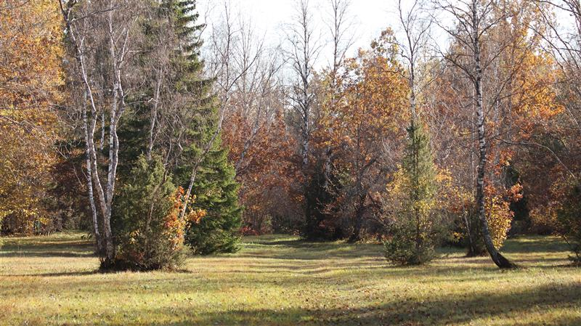
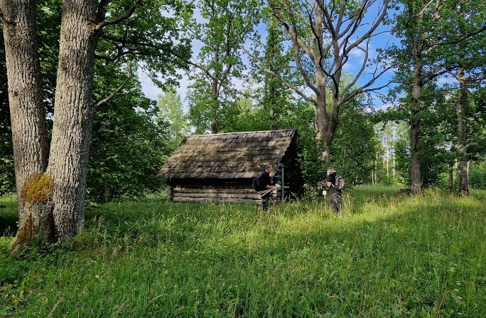
Kalli-Nedrema

Figure 2. Nedrema in autumn colors, October 2024. Photo: Meelis Suurkask
Figure 1. Nedrema old barn in July 2024. Photo: Reet Vaiksalu
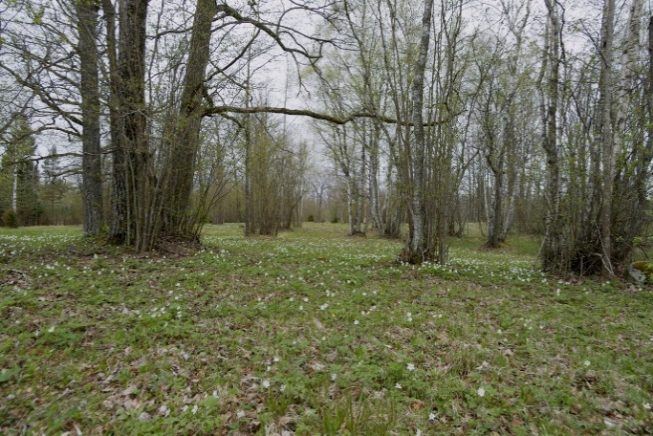
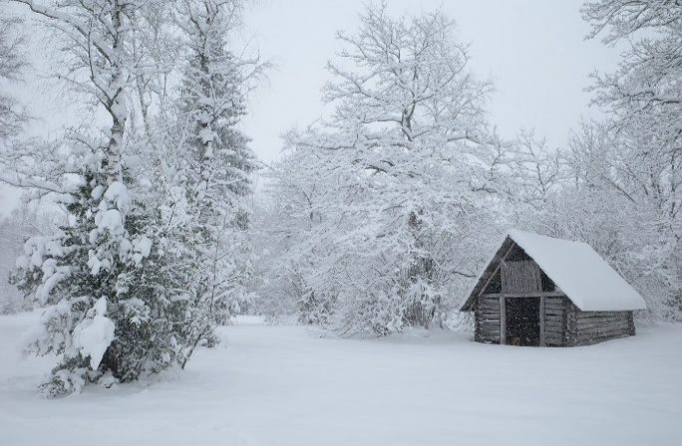

Figure 4. Nedrema in May 2008. Photo: Heikki Luhamaa
Figure 3. Nedrema in December 2022. Photo: Tiit Hallikma
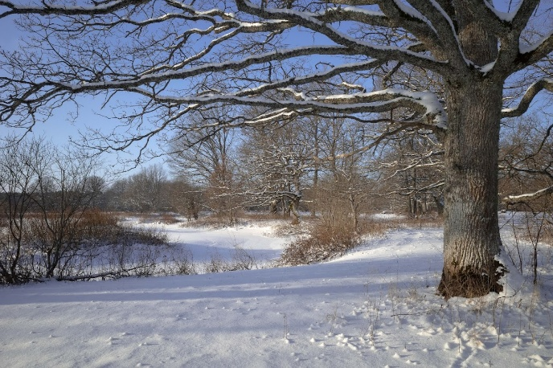
Halliste
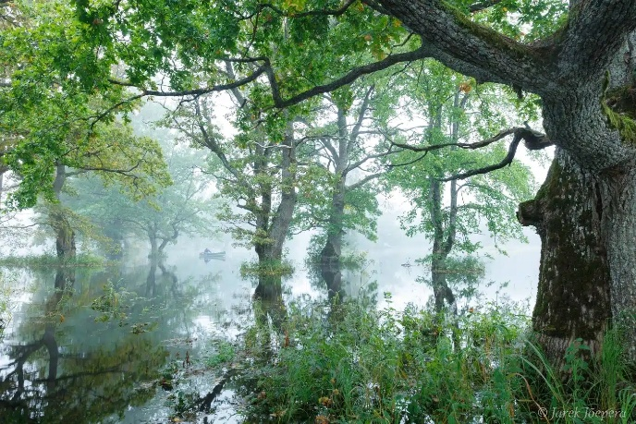

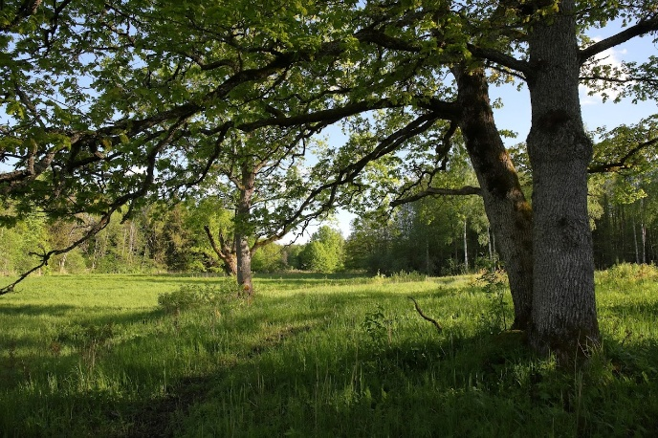
Figure 6. Halliste wooded meadow in winter January 2026. Photo: Tiit Hallikma
Figure 5. Halliste wooded meadow in fifth season august 2016. Photo: Jarek Jõepera

Figure 7. Summer is about to start in Halliste wooded meadow May 2021. Photo: Toomas Kalda

Koiva
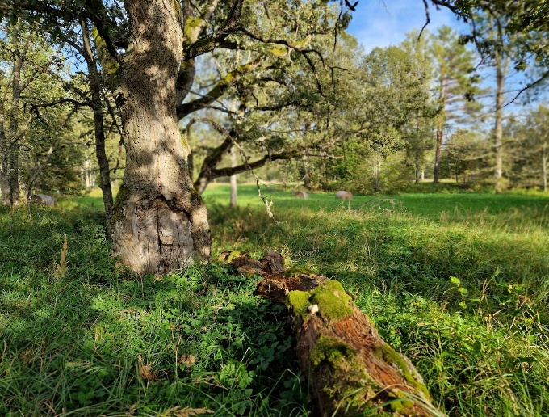
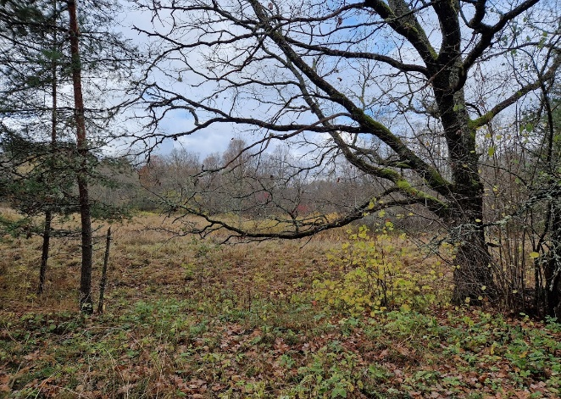

Figure 8. Summer is ending in Koiva wooded meadow Sept 2024. Photo: Reet Vaiksalu
Figure 9. Autumn in Koiva wooded meadow Oct 2022. Photo: Heidi Öövel

Loode
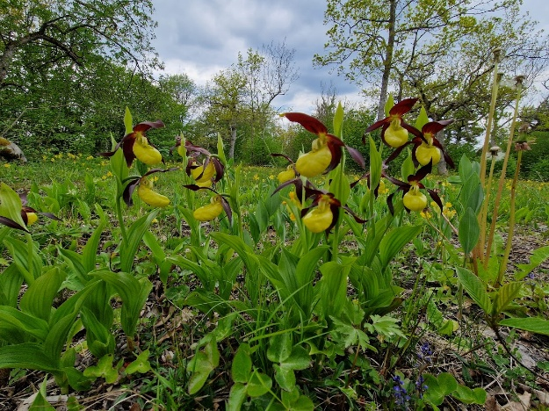
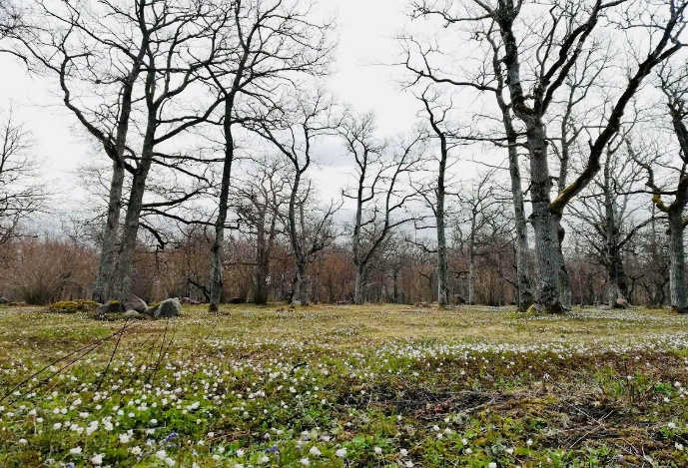
Figure 11. First bloomers in Loode Oakforest, End of May 2025. Photo: Reet Vaiksalu
Figure 10. Anemones in Loode Oakforest, May 2022. Photo: Heidi Öövel

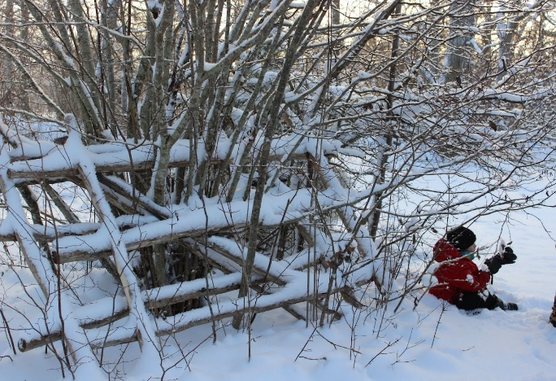
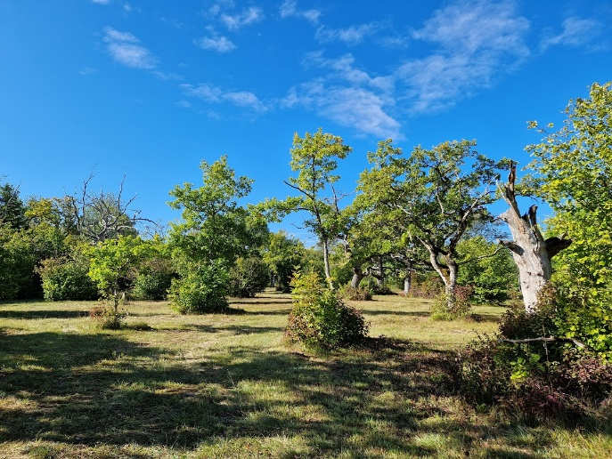

Figure 12. Hay making is completed in Loode Oakforest, Sept 2024. Photo: Reet Vaiksalu
Figure 13. Haystack ladder in Loode Oakforest, Jan 2024. Photo: Heidi Öövel

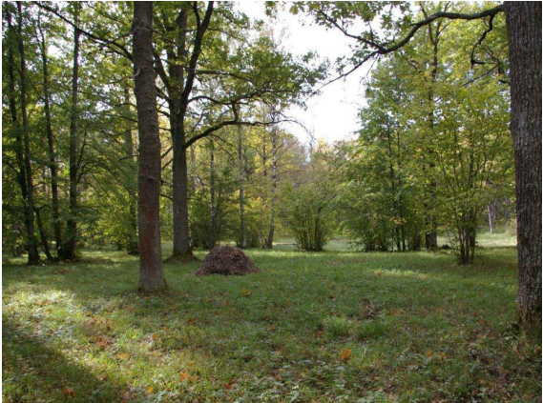
Tagamõisa
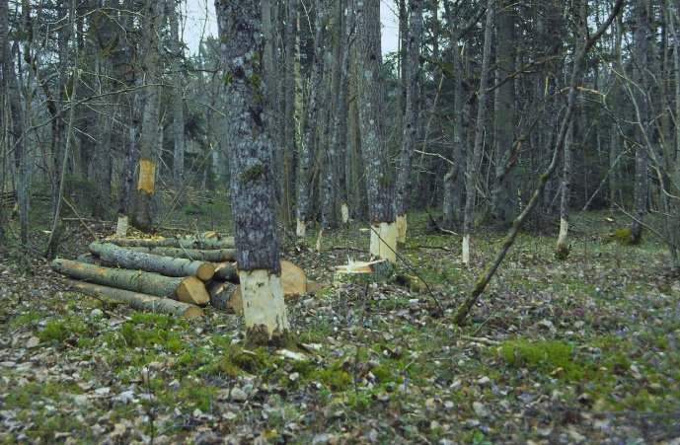
Figure 15. Haysack in the late summer. Photo from Tagamõisa Management Plan.
Figure 14. Traditional way of restoring wooded meadow in spring, Tagamõisa. Photo: Heikki Luhamaa

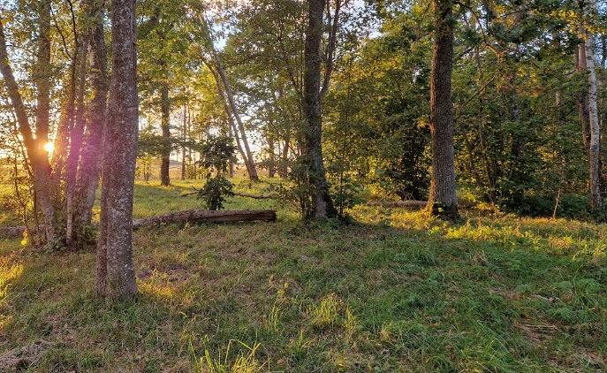
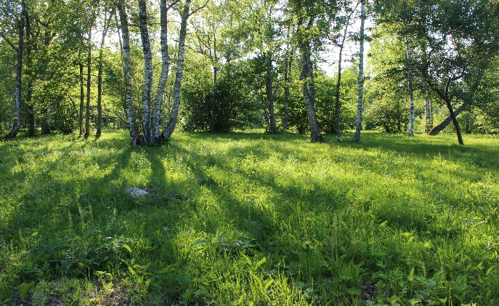
Laelatu
Figure 16. Summer in Laelatu wooded meadow, June 2023. Photo: Nele Sõber

Figure 17. Autumn in Laelatu wooded meadow, sept 2023. Photo: Reet Vaiksalu

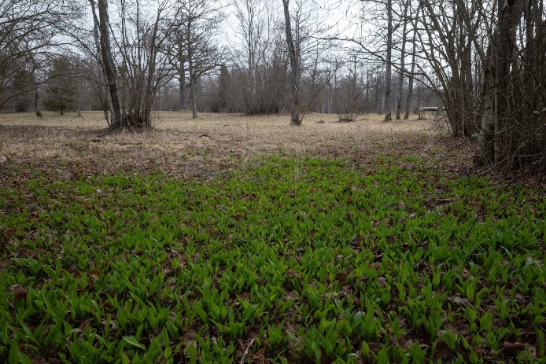
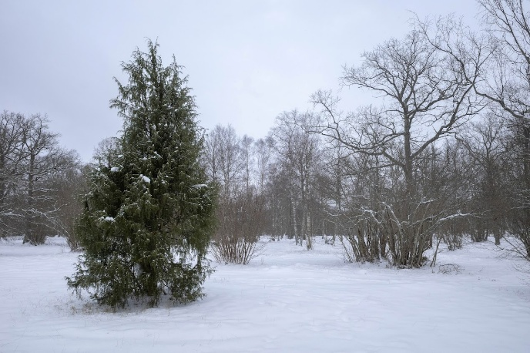
Figure 18. Winter in Laelatu, Jan 2026. Photo: Tiit Hallikma
Figure 19. Local people are using Allium Ursinum to get first vitamins from nature after winter. Spring in Laelatu, April 2025. Photo: Tiit Hallikma

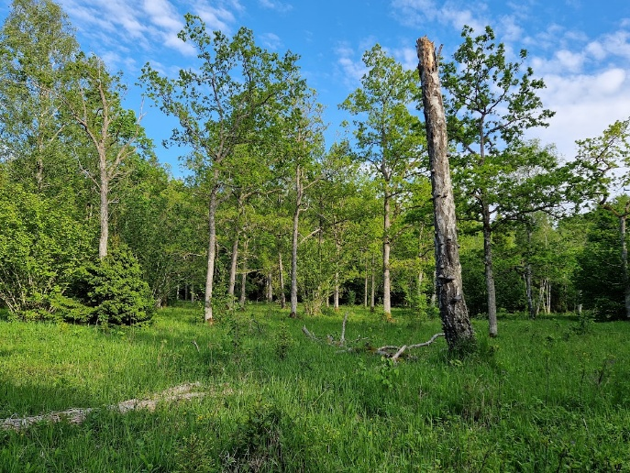
Laasma
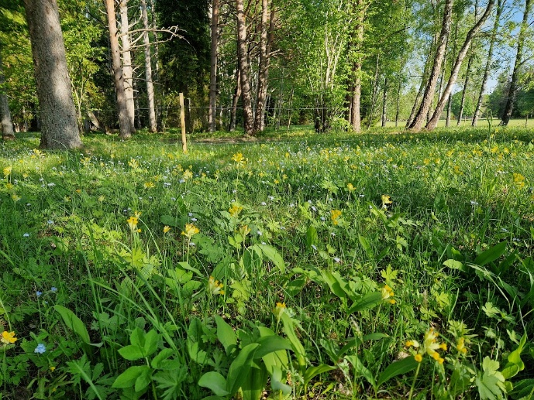
Figure 20. Primulas and Myosotis in Mäepä wooded meadow neighbouring Laasma May 2023. Photo: Heidi Öövel
Figure 21. Old tree drunks are left to the meadow as a habitat for many species. Laasma May 2023. Photo: Reet Vaiksalu

- ICOMOS understands that this land use was widespread, and the areas of wooded meadows were much larger; therefore, it would be grateful to receive historic cartographic documentation, if any is available, showing the consolidated extension of the wooded meadows as these may have been documented in the past.

The map below provides an overview of the historical distribution of wooded meadows. It is based on the results of vegetation mapping carried out by botanist Liivia Laasimer in the 1960s, which offered a comprehensive overview of plant communities in Estonia and their distribution in the mid-20th century. Wooded meadows were widespread throughout Estonia, with the highest concentration in Western Estonia and on the islands. For comparison, areas currently preserved as wooded meadows are shown in dark green, while areas receiving support for wooded meadow management are indicated in yellow.
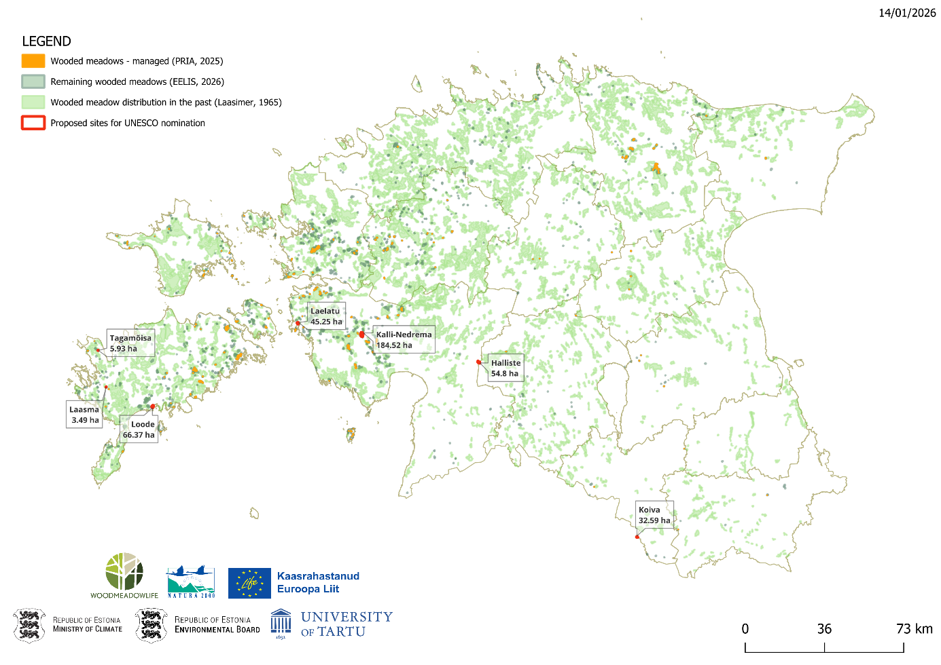
- Cartographic documentation showing the location of historically associated settlements, villages or hamlets where the communities that took (and if existing, still take) care of the wooded meadows lived (or still live) would be useful as well as information on whether their inhabitants are still engaged in the traditional practices.

The following maps use Schmidt’s/Rücker’s 19th-century Livonian base maps, with the locations of present-day villages added (shown in black text). Remaining wooded meadows are marked in green. The legend of the historical map can be found on the link: https://www.digar.ee/viewer/et/nlib-digar:46487/16022.
Estonia has a dispersed settlement pattern, which is why villages are located at some distance from wooded meadows. At several proposed sites, the management of wooded meadows has partly been continued by generations (Nedrema, Laasma, Laelatu). As most of the proposed sites are located on state-owned land, the tenants who manage them may be local residents, but this is not necessarily the case.

Tagamõisa
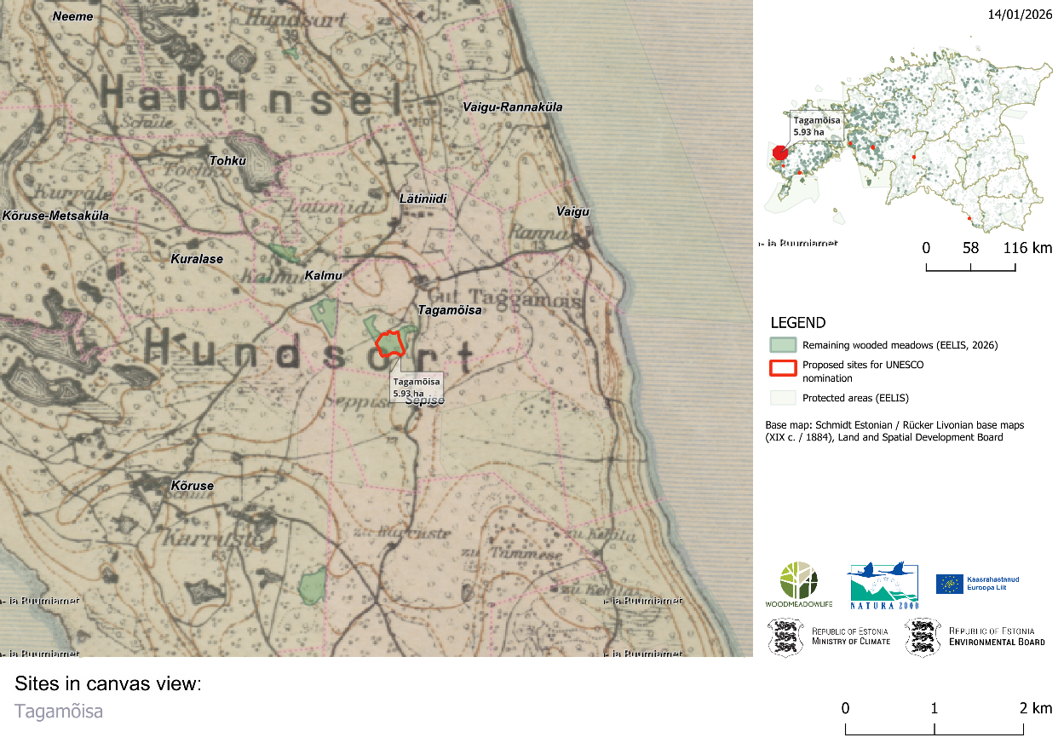
Laasma
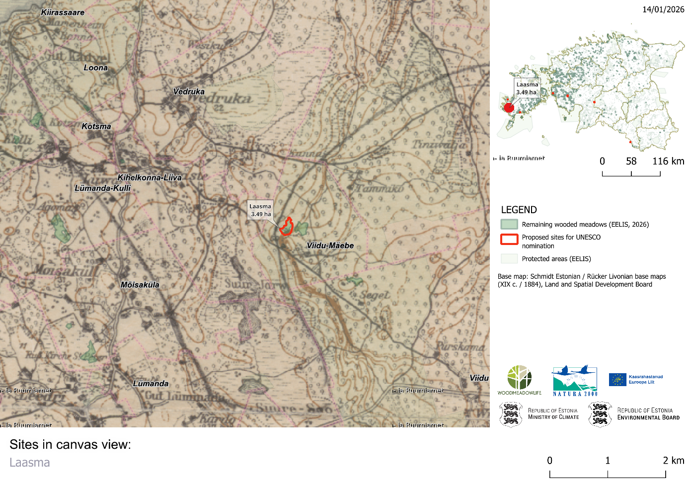
Loode
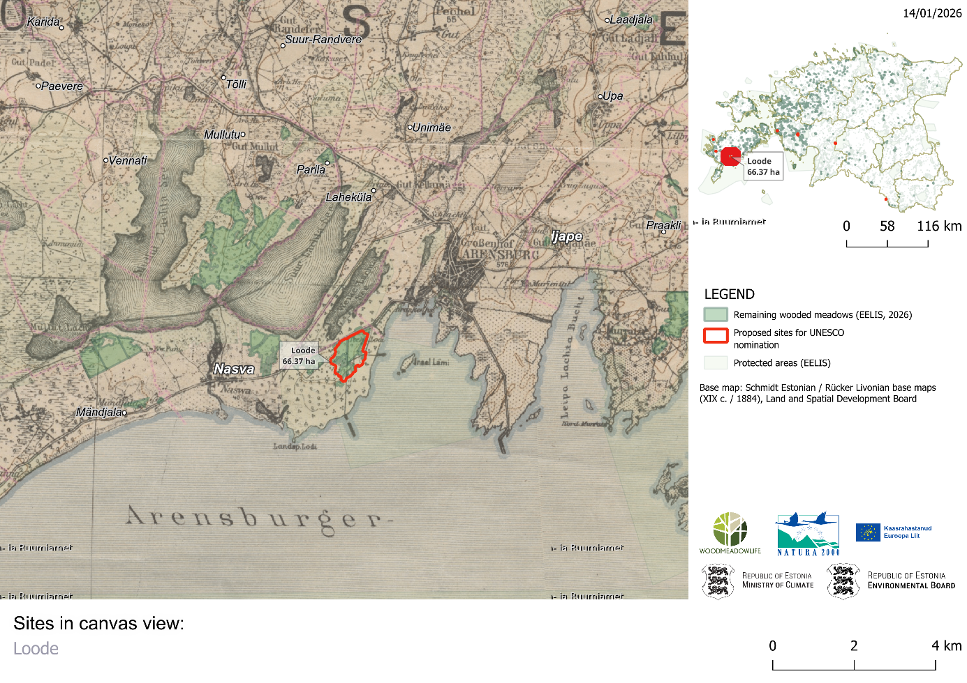
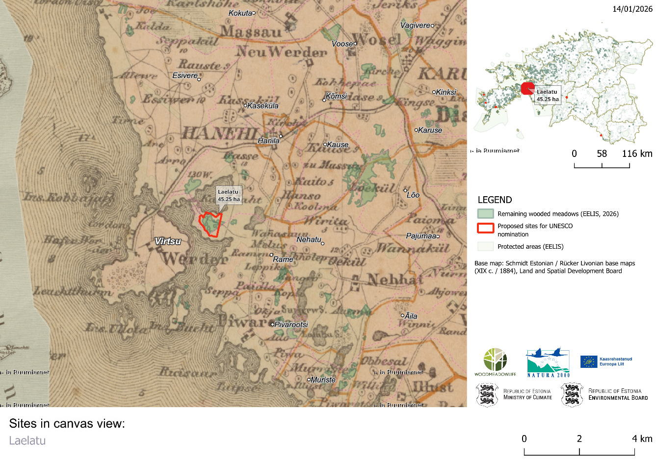
Laelatu

Kalli-Nedrema
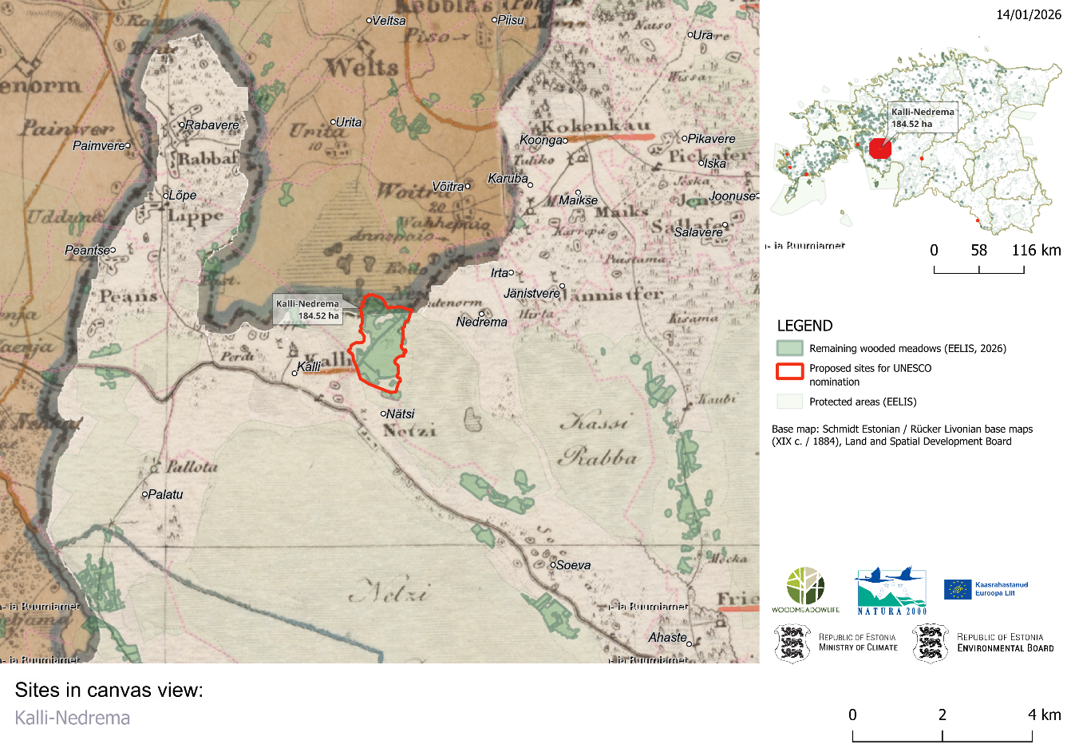
Halliste
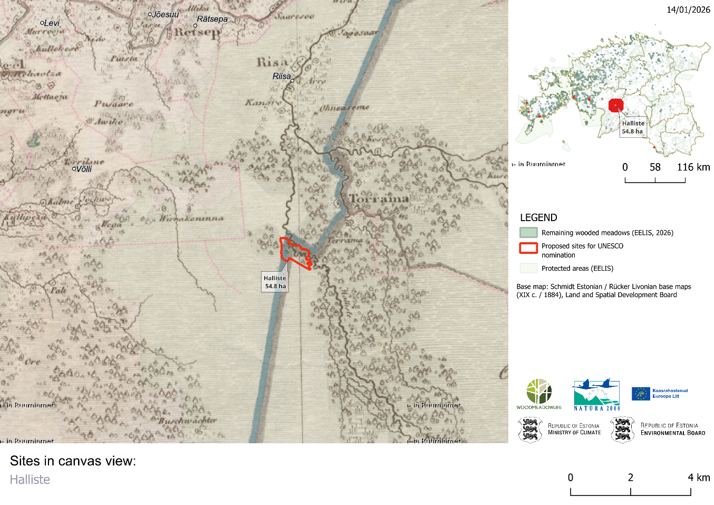
Koiva
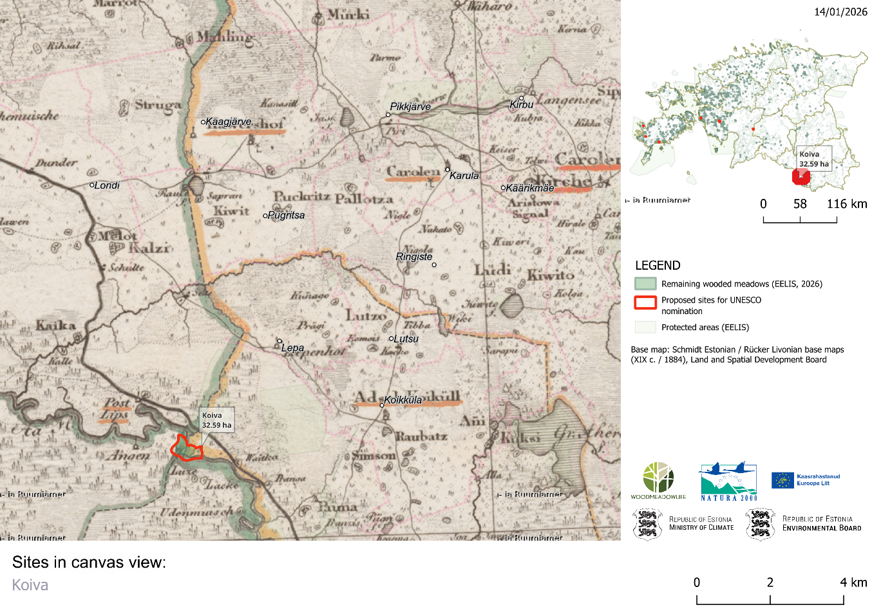
- IUCN and ICOMOS would be grateful if the State Party could provide an additional map demonstrating roughly the location of the full extent of the remaining 1100 hectares of wooded meadows across Estonia, if available.

For comparison, areas currently preserved as wooded meadows are shown in green, while areas receiving support for wooded meadow management (in protected areas) are indicated in yellow.

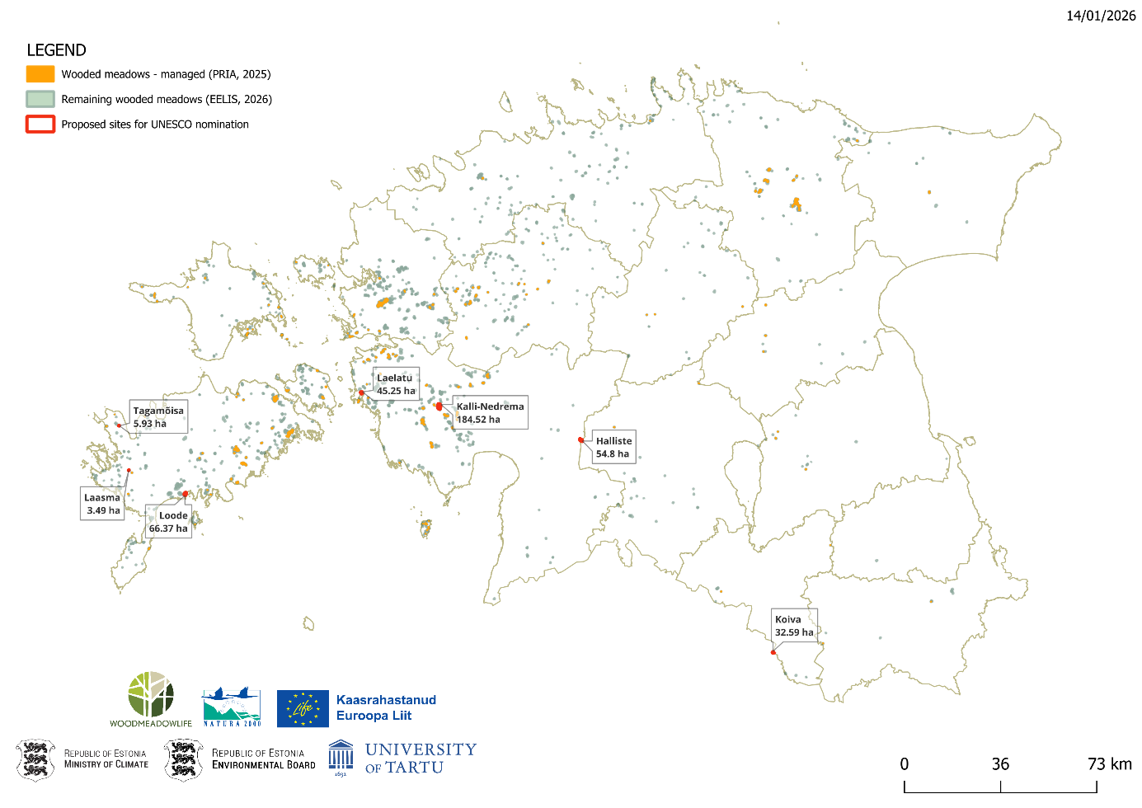
- In addition, IUCN and ICOMOS would be equally grateful if the State Party could provide land-use and vegetation maps of the wider areas surrounding each of the proposed component parts of the potential nominated property, if available.

The following maps show the land use in the vicinity of the potential nominated property. For the most part, the wooded meadows are surrounded by natural forests, wetlands or semi-natural grasslands. For semi-natural grasslands, the management type is indicated separately. For agricultural land, it is specified whether it is cultivated arable land, fallow arable land, or grassland. Please see the legend for the basic map on p 15.

Koiva
As the Koiva wooded meadow borders the Latvian state border on one side, this area has been left blank (white) on the map.

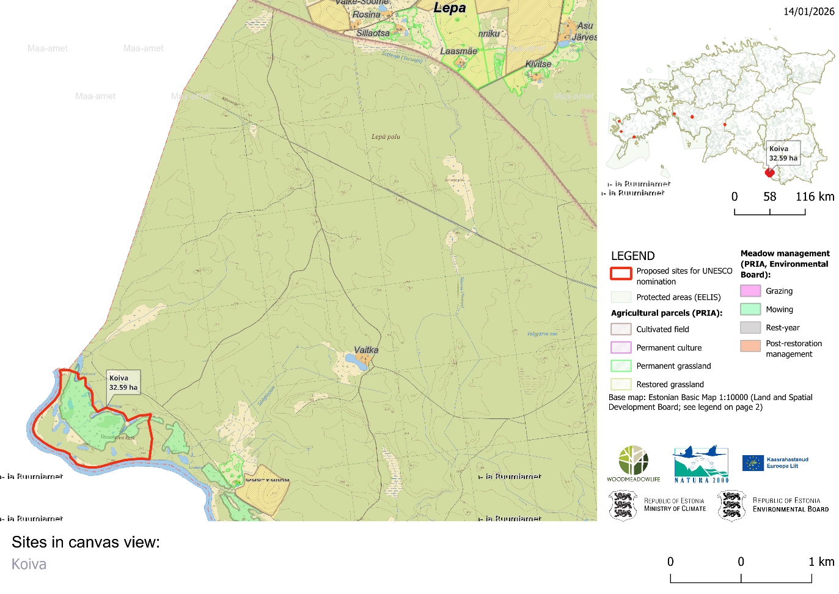

Halliste

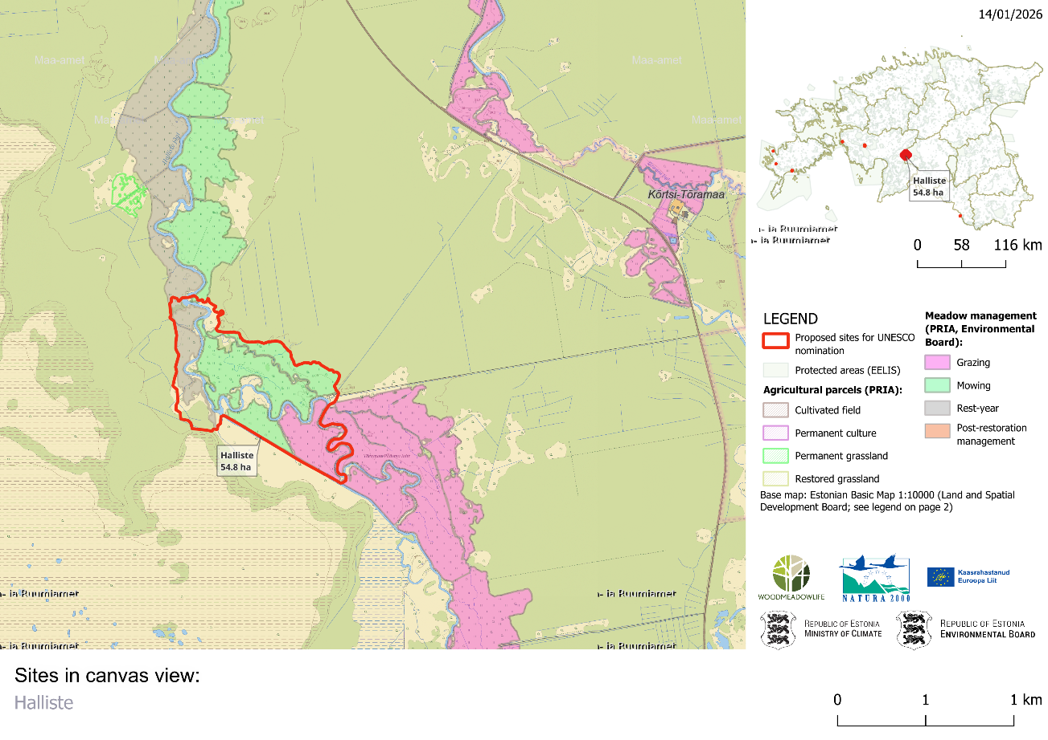

Kalli-Nedrema

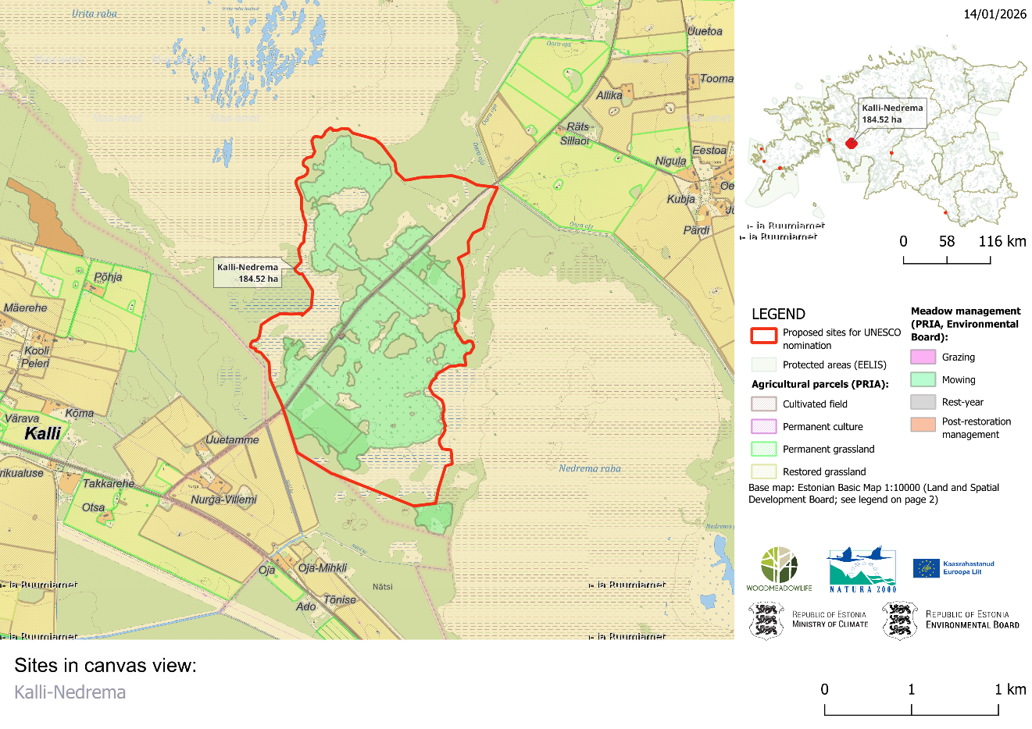

Laelatu

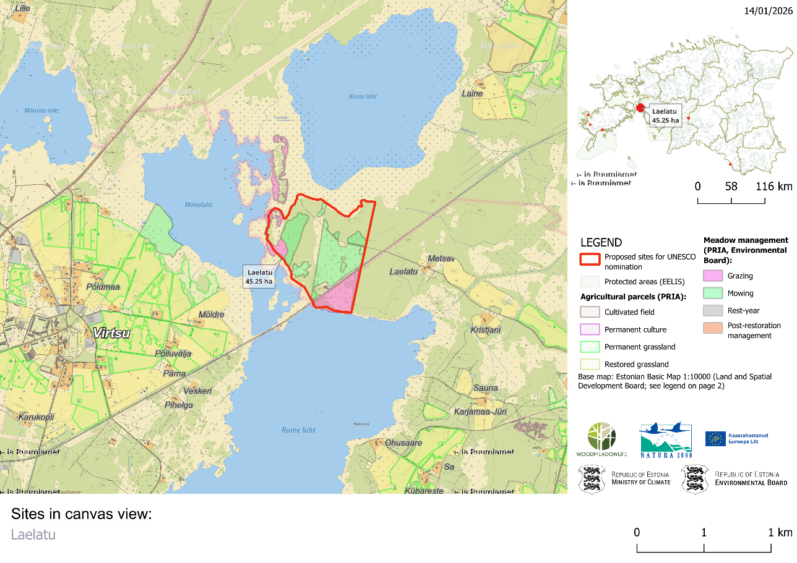

Loode

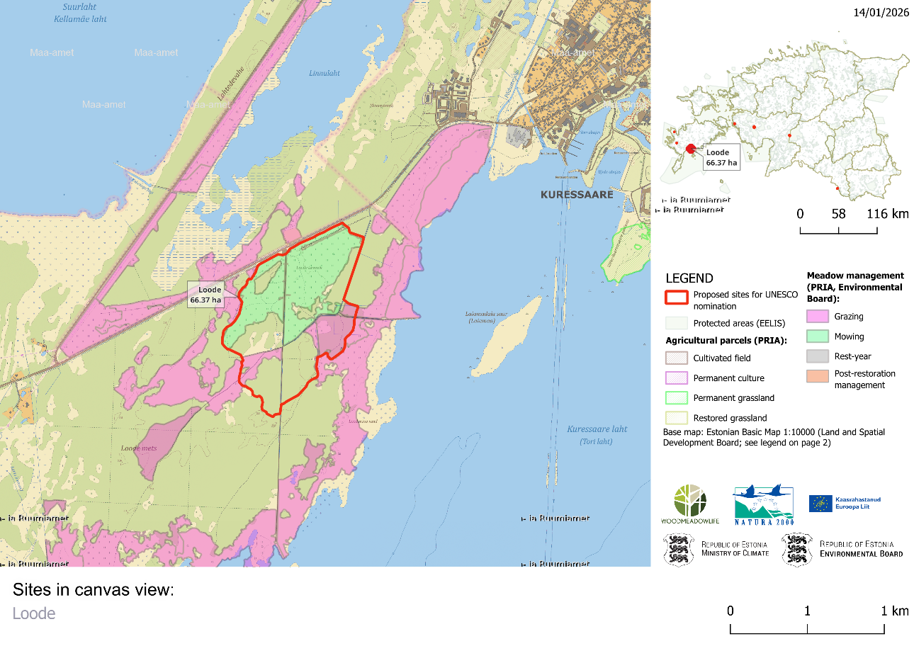

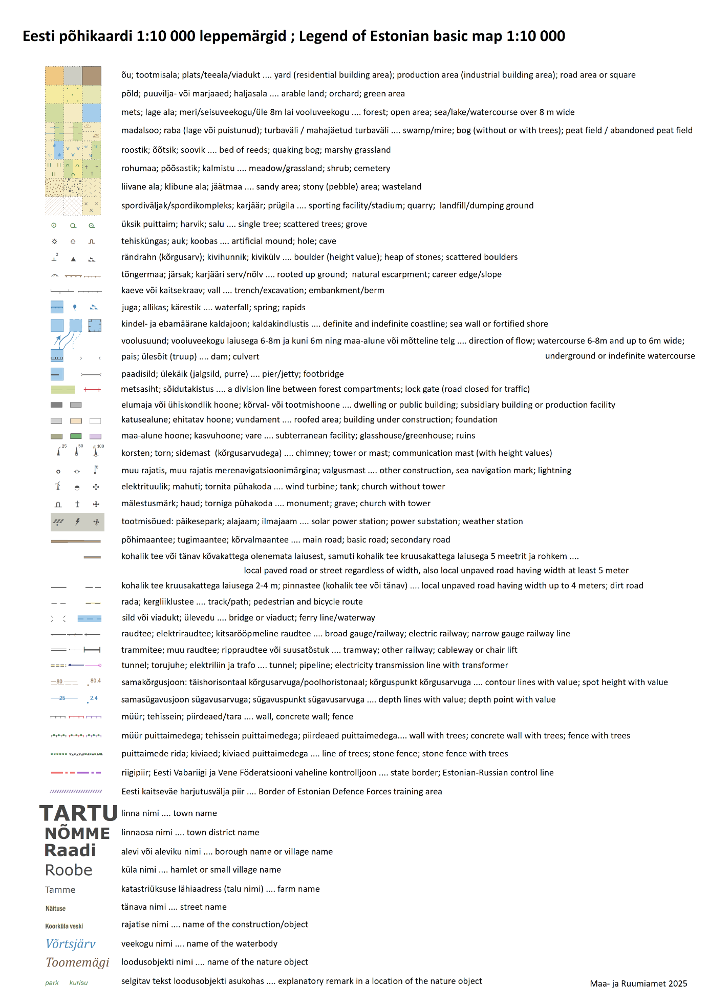
B. Historic development
- ICOMOS would be grateful to receive some further explanations about the changes that occurred over the last 200 years, particularly under the Soviet regime, and in the post-Soviet period, and how and to what extent traditional practices were maintained and/or recovered. Additionally, ICOMOS would appreciate receiving information on where these practices are still used in Estonia and in the broader Fennoscandian region, if this is the case.

Village life in Estonia has historically been strongly connected to the organization of land ownership and land use, and it has continuously evolved depending on social, economic, and political changes. Probably already by the end of prehistoric times, the distribution of fields into various shapes and sizes became permanent among community members and farm families. This was characterized by the principle of communal equality: all households were meant to be in economically equal conditions so that every family could use land with both more fertile and poorer soil, as well as land located both closer to and farther from home.
In Estonia, land reorganization from the period with better documentation is connected to the regulation of agrarian conditions that began at the end of the 18th century, and later to the maps created in connection with the early 19th-century peasant laws and regulations for crown manors. Despite changes in land management, the old communal principle remained, according to which each household or farm was allocated a greater or lesser number of separate pieces of field land from various parts of the area.
Initially, meadows were used collectively by the whole village, but over time, instead of jointly harvested hay being shared, larger and better meadows began to be distributed among families. There are records about the division of haylands from the 16th century, and maps from the 19th century show that meadows were mostly divided among farms. The forms of distribution were similar to the division of fields – from patches of various sizes and shapes to fairly regular strips – and these were used even within the same village. Often, the meadows of one village and farm were located in several places, sometimes mixed with the meadows of other villages and manors. As with fields, better meadows were protected from freely wandering animals before mowing by enclosing them with fences and ditches.
Around the mid-19th century, the fencing of farms began as part of parcellation process, meaning the separation of village lands into distinct, enclosed holdings for each farm, which included fields and farmyards as well as hay and grazing lands and forests. Different forms of fencing developed in various regions of Estonia, which strongly influenced the development of villages and the overall settlement pattern. Villages with larger, mostly as compact as possible, field areas emerged only as a result of this development. The division of fields and pastures into long strips and other shaped plots sometimes required the relocation of farmyards – old farmyards that were interspersed with other farms’ lands were replaced by new fenced plots. As a result, villages dispersed and the village form became more sparse, leading to scattered settlements. In some regions, such as on Saaremaa, where efforts were made to preserve the old farmyard locations, did the traditional village forms remain relatively intact.
Few completely unified holdings were formed, because due to Estonia’s natural conditions – especially the mosaic of fields and pastures – many farms remained in several separate land parcels. Fencing fundamentally changed the old communal land use: both fields and other lands were divided among farms, turning each farm into an independent economic unit that could operate independently of others.
Agriculture has been the backbone of Estonia’s economy for centuries. Industrialization began relatively late: modern industries and urbanization started to develop only after the 1870s. During Estonia’s period of independence from 1918 to 1940, Estonia remained predominantly an agricultural country.
Until the mid-19th century, the countryside was dominated by foreign nobility, while Estonians largely belonged to the peasantry and were subjected to serfdom. Land use was strongly determined by social conditions – the countryside was divided among about 1,200 manors that governed the villages. Although the first laws abolishing serfdom were passed as early as 1816, peasants actually gained the rights to free movement, ownership, and land use only in the last third of the 19th century.
Villages were geographically diverse – coastal areas, plains, hilly regions, river surroundings, and soil fertility gave each region its own character. Generally, villages in Estonian rural areas had dispersed settlements, usually with 8–15 farms located in distance from one another. On the islands and in coastal areas, villages were denser because livelihoods were earned from seafaring due to poorer soil. Village size rarely exceeded 20 farms. The most fertile and largest fields were used by the manors, and peasants were given smaller plots of land near the villages. Better fields were mainly used for crop cultivation, livestock were grazed on poorer soils, at forest edges, and elsewhere. Hayfields were needed to obtain large hay resources to sustain livestock over the winter. Since there was little arable land, hay was often made in bogs or open forest areas – this prevented these areas from becoming overgrown and helped maintain species diversity. The low intensity annual hay-making that continued over centuries was the most important feature maintaining the ecological functions of wooded meadows. It was also a cornerstone of rural cultural life with community coming together to work and socialize.
The Soviet occupation (1940–1941 and 1944–1991) brought extensive industrialization and urbanization, and immigration also influenced society. Rural areas were radically changed by collective farms. During the Soviet era, all land was nationalized, and traditional fields were combined into giant fields managed by collective farms. Many people moved to larger settlements that were supposed to encourage modernization, more importantly, however, this reflected the Soviet emphasis on strengthening social control. Many remote farms were abandoned or demolished to expand fields, and several meadows grew over with brush. Farmers were forced to join collective farms but were allowed to keep only a few domestic animals and use a small portion of arable land as private plots. Although many fields were adapted for mass production, and developing small haylands proved impractical for collective farms, people still continued to use wooded meadows at their own homesteads. Therefore, the traditional practices were kept alive even in the Soviet era and the cultural and social significance of wooded meadows was recognized by local communities.
After Estonia regained independence in 1991, there was a strong desire to revive traditional Estonian farming lifestyles, but many were unable to succeed under changed economic conditions. Today, most land is cultivated by large farms that own or lease fields, and agricultural production has largely been reorganized under market economy conditions. However, the ecological and cultural value of wooded meadows continues to be highly recognized at both community and state level. A revival of interest in these landscapes began in the 1990s, as accumulating scientific evidence of their valuable characteristics sparked wider public and institutional awareness. This newfound recognition then translated into concrete conservation action from the late 1990s onwards that has continued to this day. While the practical necessity of ensuring fodder for livestock has diminished, the ecological and cultural importance of these landscapes strongly remain. Their management still relies on local ecological knowledge and skills passed down through generations, although the concrete practices and use of the meadows have changed and evolved over time. In addition to providing hay, they now serve also as now serve also as field classrooms, conservation hubs, and destinations for ecotourism and education, having survived a centuries of transformative agricultural and societal change.

- ICOMOS would appreciate receiving further information about past governance arrangements, including land-use, ownership, labour organisation, and whether any elements of these arrangements still exist today and about actions to recover what was disappearing or disappeared.

The heyday of wooded meadows in Estonia was at the end of the 19th century, when semi‑natural grasslands, including wooded meadows, covered approximately 850,000 ha, or about 18–19 % of Estonia’s land area. At that time wooded meadows were especially common in Western and Northern Estonia and on the islands.
After this peak, the extent of natural grasslands began to decline, as the more easily cultivated areas were converted into arable land or more intensively managed cultivated meadows. The decline of wooded meadows was relatively slow until World War II.
The first major driver of the loss of wooded meadows was the collectivization of agriculture in the 1950s. During the Soviet period, farms were reorganized into collective and state farms, and land and livestock were collectivized. Although rural households could keep a few animals privately, the overall need for hay from traditional meadows decreased.
However, the main reason for the decline was the abandonment of traditional small‑scale management practices in favour of large‑scale, intensive agriculture. As traditional hand‑mowing and grazing practices were replaced by mechanized farming and the focus shifted to fertilized, cultivated grasslands, wooded meadows were left unmanaged and began to overgrow. A similar shift towards intensive agriculture has also been the primary cause of semi‑natural grassland loss in Western Europe.
A revival of interest in these landscapes began in the 1990s as described in point B.1.Today, the management of wooded meadows in Estonia is governed by national environmental and agricultural policies. Wooded meadows have been preserved as semi‑natural habitats in Estonia, and the traditions of their management — together with their cultural and historical significance for Estonians — are highly valued at the national level. The conservation and sustainable management of these habitats are supported through instruments such as the Nature Conservation Act, the Action Plan for Semi‑Natural Grasslands (Link: https://www.keskkonnaamet.ee/sites/default/files/documents/2022-09/ENG_Action%20plan%20for%20semi-natural%20grasslands.pdf), and the Maintenance and Restoration Guidelines for Wooded Meadows (Link: https://www.keskkonnaamet.ee/sites/default/files/documents/2022-09/Maintenance%20plan%20for%20wooded%20meadows%20and%20wooded%20pastures.pdf). These frameworks set out legal protection, restoration principles, management practices, and support mechanisms to ensure that wooded meadows are maintained, restored where necessary, and remain viable both ecologically and culturally into the future.

C. Attributes under criterion (x)
- IUCN would be grateful to receive a summarised species list, limited to those species considered threatened (according to the IUCN Red List of Threatened Species), endemic or near-endemic, or of general importance to the potential nominated property, alongside a total species number, if available. The attached table, in the annex, may be used to provide this information.

The Estonian Ancient Wooded Meadows support exceptionally high biodiversity across multiple taxonomic groups, shaped by centuries of continuous, low-intensity management. Recent inventories within the nominated property have documented 542 species of vascular plants, 107 bryophytes, 64 Lepidoptera species (incomplete), 65 Hymenoptera species (incomplete), and 54 bird species, among others.
Global IUCN Red List assessments were conducted for species identified during the past four years from the following groups: vascular plants (Tracheophyta), fungi (Red-Listed species only), and selected animal taxa (Hymenoptera, Lepidoptera, Coleoptera, Aves, Mammalia). Of these, five species are currently classified as globally threatened (Vulnerable, Endangered, or Critically Endangered), and eight as Near Threatened. These numbers, however, likely underrepresent the true conservation significance of the site due to gaps in global Red List coverage, particularly for invertebrates and fungi, as well as the incomplete status of current inventories for some invertebrate groups.
At the regional level, number of species are listed in European Red Lists, the Annexes of the EU Habitats and Birds Directives, or are protected under Estonia’s national legislation. These listings reflect well-documented declines of grassland species across Europe and highlight the critical role of Estonia’s wooded meadows as part of critical refugia for threatened semi-natural grassland biodiversity.
Particularly notable are the habitat-specialist orchids, epiphytic lichens, old-growth-associated saproxylic beetles, and meadow-dependent bird species, which reflect the ecological and conservation significance of this biocultural landscape. The wooded meadows also serve as living laboratories of species coexistence, long-term ecological memory, and adaptive traditional management. Although inventories of insects and fungi are still ongoing, species richness in these groups is expected to be significantly higher than currently presented.
Annex, Estonia Ancient Wooded Meadows species lists IUCN

D. Historic and contemporary local communities
- Further information about the communities that practiced (or still do, if this is the case) traditional management and related activities to sustain themselves and their socio-cultural system would be useful.

Traditional management of wooded meadows was widespread throughout Estonia. These were places where hay was mown for animals’ winter feed and where young spruce branches were made into larch whisks, which enriched the animals’ winter diet.
Today, traditional mowing with a scythe has somewhat changed — hay is cut using trimmers, motor blocks, or other mowing machinery. However, there are still communities and landowners who consider the tradition of maintaining wooded meadows important, both among older and younger generations.
As part of the WOODMEADOWLIFE project, a study on the cultural heritage of wooded meadows was conducted, and one of the interviews was done with a local resident of Nedrema, Sirje Koppel, and her husband Jaan Koppel, who has by now been involved in farm life in Nedrema for decades. Excerpt from the report : “Jaan’s brother Jüri is a wooded meadow caretaker on Saaremaa Island. The Koppels maintain their wooded meadow according to their own principles; they do not want subsidies, and their meadow looks different from so-called industrially managed ones—denser, wilder, and more shrubby. They still live next to her childhood wooded meadow, Rebastroose. During the interview, she showed the spring, the former barn sites, and large trees, and at the same time collected brushwood from the ground. Afterwards, Sirje Koppel showed the Vainu farm barn on the other side of the road. Near the barn, Sirje picked up a scythe found there and mowed a little. Jaan Koppel also demonstrated mowing techniques under the threshing barn.“
On Saaremaa Island, there are several wooded meadow managers who remain strongly committed to traditional ways of managing wooded meadows. In Võrsna, there is a landowner, Veiko Maripuu, who manages his childhood wooded meadows and has also involved his daughter in farm work. Their organic farm manages both wooded meadows and wooded pastures. Restoring old wooded meadows in a traditional manner is very important to him. The selection of trees to be cut and the timing of cutting are carried out carefully, in a highly considered way and without haste. The meadows gradually open up as the canopy cover is reduced step by step. Traditional mowing is also very important to him, and he uses a scythe, as he feels this method is better for the hay—the cut is clean and straight. The hay is fed to the sheep they raise. He is very happy to see how long-term management enriches the meadow and how different orchid species have spread to his meadows.
In Estonia, it is quite popular to participate in volunteer work camps, where each year some wooded meadows are mown by hand with the help of volunteers. So-called “summer schools” have a long tradition: during the day, participants mow with scythes and select the best mower (the “meadow hero”), after which the hay is gathered. After the hard work, the day typically ends with a traditional sauna, followed by an interesting lecture or a concert.
In western Estonia, in the Matsalu area, there is also a community that continues to manage a local wooded meadow collectively. When the hay has been cut and raked, the local villagers who have helped with the haymaking gather in a traditional smoke sauna to talk about life and the wider world. The local landowner and meadow manager, Raul Oberschneider, shares his thoughts on why wooded meadows should be maintained in the video “Wooded meadows are managed only for yourself.”
Link to the video: https://youtu.be/n8KKsnMG3TQ?si=EIuKyPUZYg3wy8b3
In Estonia, there is a tradition of recognising and valuing managers of semi-natural habitats, and Raul Oberschneider has been among the nominees for this award.

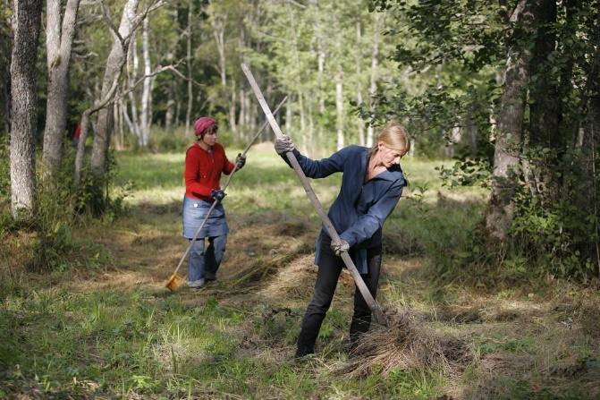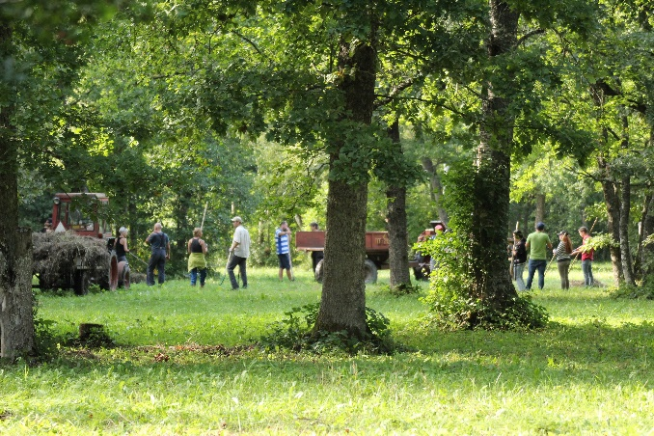
Figure 2. A community that continues the collective management of the local wooded meadow. Photo: Peeter Hermik
Figure 1. A community that continues the collective management of the local wooded meadow. Photo: Peeter Hermik

E. Protection and management
- Concerning the management of the ‘Estonian Ancient Wooded Meadows’, IUCN would be grateful to receive the current management plan of the Kalli-Nedrema / Nedrema Nature Reserve component part and the Laasma / Viidumae Nature Reserve component part. If documents are only available in Estonian, IUCN would appreciate a short additional summary of the management plan in one of the two working languages of the World Heritage Convention (English or French), in addition to the full Estonian language plan.

The management plan for Nedrema Nature Reserve was completed in 2015 (Link: https://eelis.ee/getdok/453030650) and includes, among other things, the conservation management of the wooded meadows within the protected area. There are no plans to update the protection regulation this year, but it will be reviewed in the coming years. Since the management plan is available in Estonian, here is a brief summary of the section on wooded meadows in English:

Wooded meadows (6530)
Nedrema wooded meadow is one of the largest wooded meadows in Estonia and all of Europe. At the beginning of the 20th century, the area of the Nedrema wooded meadow was 200–250 hectares, divided between 32 different landowners.
Long-term management of the Nedrema wooded meadow has influenced competition between plant species and promoted diverse coexistence, with 236 different vascular plant species recorded from the meadow.
The inventoried area of this habitat type is 155.4 hectares. The Natura 2000 database sets a target of 240 hectares of wooded meadow. In terms of species density, Nedrema wooded meadow is among the average in Estonia, with 54 vascular plant species found per square meter. Nineteen protected vascular plant species have been recorded there, of which 15 are orchid species (Pärnumaa Loodus). Five rare mushroom species have been found in Estonia. Forty-seven protected bird species have been recorded, most of which are associated with wetland habitats (appendix 7).
The survival and maintenance of the wooded meadow as a representative habitat may be threatened by declining interest from caretakers, which is related to subsidy levels, difficulties in management (stones and stumps damage machinery), and the utilization of the harvested hay. The hay from the wooded meadow is not of high nutritional value for animals, and this is further reduced by late mowing.
Long-term conservation goal: the habitat type wooded meadows is maintained over an area of 155.4 hectares with condition class A.
Conservation period goal: the habitat type wooded meadows is maintained over an area of 155.4 hectares with condition class A.
Threat factors:
- Drainage
- Overgrowth with bushes and trees
Measures:
- Restoration of natural water regime, closing the ditch originating from Nedrema lake
- Annual mowing and removal of hay
- Removal of bushes and reduction of tree cover connectivity

The management plan for Laasma/Viidume Nature Reserve was also completed in 2015 and right now renewing the management plan is in process and will be completed during 2026. Link for the management plan in Estonian: https://infoleht.keskkonnainfo.ee/getdok/1952166920. Following is a short summary of management plan on wooded meadows in English:

Wooded Meadows (6530*)
Three wooded meadows have been inventoried in the Viidumäe Nature Reserve in the Viidumäe study area – Laasma, Mäepea, and Upsi, which are located in the Suurmäe maintained conservation zone and the Audaku limited management zone. A small part extends into the Tõldemäe conservation zone. The representativeness and conservation value of the Laasma and Mäepea wooded meadows are very good. There are no assessments of the representativeness and value of the Upsi wooded meadow. The wooded meadows are to be maintained during the planning period.
The communities belong to the dry calcareous grassland habitat type (2.1.4.1) and the Oxalis-Myrtillus site type (1.1.4.1).

Long-term conservation objective: The area of wooded meadows is at least 7 hectares with an “A” level of representativeness.
Conservation objective for the management period: The area of wooded meadows is at least 7 hectares with an “A” level of representativeness.

Impact factors and measures:
- Insufficient maintenance, overgrowth, and afforestation.
Measure: Continuous annual mowing of wooded meadows (in the second half of July) together with hay removal and gathering of fallen branches.
Measure: Thinning of shrub layer and growing undergrowth as needed.
- Damage to meadow vegetation (including orchids) caused by wild boars.
Measure: Early spring leveling of wild boar rooting traces (manually with a rake or using machinery with a blade).
Measure: Controlling wild boar populations by hunting.
Measure: Prohibition of supplementary feeding of game animals, which may be allowed at the discretion of the protected area manager according to §14, point 10 of the Nature Conservation Act. The protection rules will be updated to include a ban on supplementary feeding of game in the protected area.

Management plan for wooded meadows and wooded pastures
In addition to individual management plans, an overall management plan for wooded meadows and wooded pastures was prepared in 2019 to address issues relevant across all wooded meadows and wooded pastures, (Link:
https://keskkonnaamet.ee/sites/default/files/documents/2021-06/Puisniidu_puiskarjamaa_hoolduskava.pdf), which provides an overview of the concepts, origin, distribution, communities, fauna, species richness, as well as the principles of restoration and management of wooded meadows and wooded pastures. The purpose of the management plan is to explain the natural and cultural values of wooded meadows and wooded pastures in Estonia and globally, and based on this, to emphasize the importance of their restoration and management. Taking into account recent research and changed circumstances (new restoration methods, more powerful mowing technology), the plan gives recommendations for the restoration and subsequent management of these heritage communities.

Action plan for semi-natural grasslands
Another important document supporting the planning of wooded meadow conservation is the Action plan for semi-natural grasslands (Link:
https://keskkonnaamet.ee/sites/default/files/documents/2022-09/ENG_Action%20plan%20for%20semi-natural%20grasslands.pdf). The action plan for semi-natural grasslands sets goals for the preservation and restoration of semi-natural grasslands, provides an overview of the current situation and risk factors, and describes activities to achieve the goals until 2027.

State support for the maintenance of wooded meadows is provided with the aim of increasing species richness. This measure is also relevant in the context of the management of wooded meadows. The measure is implemented through the European Union’s Common Agricultural Policy — the Support for Maintenance of Heritage Meadows for the Period 2023–2027. The regulation can be found at https://www.riigiteataja.ee/akt/102082025019.

